Handwritten Digits Classification Using Neural Networks
K Chaitra Latha
School of mathematics & Natural sciences
Chanakya University, Bengaluru, Karnataka, India
Abstract
This paper carries out an in-depth study on handwritten digit classification by using a basic neural network structure. The experiment explores the contribution of hidden layers to the enhancement of model performance on the benchmark MNIST dataset. We, therefore, outline the process involved in data preparation, model construction, compilation, training, testing, and visualization to demonstrate how the Adam optimizer and backpropagation can improve the training procedure. The results seem to show immense improvement in terms of the accuracies of deeper architectures, setting the stage well for neural nets to be successfully used in image recognition, and the question of data usage has been addressed concerning model deployment: responsible AI has been put in practice.
Keywords
Handwritten Digit Classification, Neural Networks, Adam Optimizer, Backpropagation, Ethical Considerations.
1. Introduction
Handwritten digit recognition is one of the significant challenges in computer vision and machine learning, with direct applications in fields such as automatic postal services and bank check processing. The MNIST dataset has 70,000 images of handwritten digits. It is one of the standard benchmarks for the evaluation of algorithms in image classification. This set offers a variety of writing styles that the researchers can use to train and test their models effectively. This paper considers a range of neural network architectures, starting with simple input-output models and increasing complexity to structures with hidden layers. We progressively add complexity systematically in order to understand how the hidden layers help improve the ability of the model to learn more complex patterns. The first model will be used as a baseline for comparison and will help illustrate performance improvements. Our study highlights the importance of model architecture in achieving higher accuracy in classification tasks. Finally, we aim to contribute valuable insights into effective neural network design for digit recognition applications.
2. Literature Review
In the literature, handwritten digit classification has been seen to be greatly revolutionized with neural networks. The ability to harness deeper architectures toward improved performance has been found to be particularly transformational. Very recently, research work by Asish et al. As observed, (2023) and Islam et al. (2022) mentioned that deep learning techniques were successful in applying to many domains ranging from postal services to banking. It was a few years back that the MNIST dataset gained the status of the benchmark, giving rise to a diverse range of handwritten digits challenging traditional approaches. Evidence exists within research that suggests CNNs described by Siddique et al. (2019) indeed outperform basic architectures with increased margins and, more importantly, better feature extraction capabilities. Again, this happens to be in contrast with foundational work, such as Goodfellow et al. (2016), which highlighted how complex structures became necessary for enhanced classification accuracy to be achieved.
Model deployment and data usage have also had more ethical concerns. According to Alzubaidi (2019) and Jain (2019), it is, therefore, fundamental to ensure the fairness and accountability in AI systems with regard to its training data; these may potentially contain biases and influence performance within different demographics. The discussion leads to the optimization techniques for controlling the learning rates. The present study shows that the learning rates are managed very well during training by the Adam optimizer. It, therefore, comprehensively outlines the progress of handwritten digit classification and sets out a future direction of research: more sophisticated models like CNNs and the possible impacts that these may have on accuracy and efficiency.
3. Methodology
3.1 Overview
The study employs a systematic approach to develop a neural network for digit classification. The methodology includes data preparation, model design, compilation, training, evaluation, and visualization of results.
3.2 Data Preparation
The MNIST dataset is divided into training and testing sets, with 60,000 images for training and 10,000 images for testing. The images are normalized to a range of [0, 1] to aid in model convergence during training.
3.3 Model Design
Two neural network architectures are considered:
- Single-Layer Perceptron (SLP): This model includes only an input layer and an output layer.
  - Performance: Accuracy of 92.5%
- Multi-Layer Perceptron (MLP): This model includes one hidden layer.
  - Performance: Accuracy of 97.1%
Further experiments are conducted by adding more hidden layers to the MLP architecture to assess improvements in accuracy.
3.4 Compilation
Models are compiled using the Adam optimizer, which adapts the learning rate throughout training. The loss function utilized is sparse categorical cross-entropy, suitable for multi-class classification.
3.5 Training
Training involves fitting the model to the training dataset for a specified number of epochs (e.g., 20 epochs), using a batch size of 32. Monitoring validation loss helps prevent overfitting.
3.6 Evaluation and Visualization
After training, models are evaluated on the test dataset. Performance metrics such as accuracy, precision, recall, and F1-score are calculated. Visualizations of confusion matrices and sample predictions provide insights into model performance.
3.7 Tools and Libraries
The following tools and libraries are utilized in this study:
- TensorFlow and Keras for model development and training.
- Matplotlib for data visualization.
- NumPy for numerical computations.
3.8 Ethical Considerations
The ethical implications of using the MNIST dataset and deploying neural networks are discussed in this section. It underscores the importance of responsible AI practices, including:
- Data Usage: Although the MNIST dataset is publicly available, researchers must ensure that their methods do not reinforce biases present in the data or lead to unintended consequences when applied to real-world scenarios.
- Model Deployment: Considerations regarding how the models are used in practice, including transparency and accountability in AI systems, are essential to avoid misuse.
- Bias and Fairness: The section stresses the need to evaluate models for fairness and to be aware of potential biases in training data that could affect the performance of the model across different demographics.

3.9 Optimization Algorithm (Adam Optimizer)
- The paper highlights the use of the Adam optimizer for training the neural network models. Adam combines the advantages of two other extensions of stochastic gradient descent: AdaGrad and RMSProp. It is particularly effective for problems with large datasets and high dimensionality. The section explains that Adam adapts the learning rate for each parameter individually, which helps in achieving faster convergence and enhances the model's performance.
3.10 Backpropagation
In this section, backpropagation is described as the algorithm used for training the neural network. It involves calculating the gradient of the loss function with respect to each weight by applying the chain rule, thus enabling the model to update its weights effectively. This mechanism allows the network to minimize the loss function iteratively and is crucial for learning complex patterns in the data. The section emphasizes that backpropagation is fundamental to the training process of deep learning models.
4. Results
4.1 Performance Metrics
Model Type | Accuracy (%) | Precision (%) | Recall (%) | F1-Score (%)
Single-Layer Perceptron (SLP) | 92.5 | 92.3 | 92.5 | 92.4
Multi-Layer Perceptron (MLP) | 97.1 | 97.0 | 97.1 | 97.0
The performance of the models is summarized below:
The MLP architecture significantly outperforms the SLP, demonstrating the benefits of incorporating hidden layers for feature extraction and representation learning.
4.2 Model comparison
Model | Epochs | Training Accuracy (%) | Test Accuracy (%) | Training Loss | Test Loss
Dense Layer (Sigmoid Activation) | 5 | 92.62 | 92.57 | 0.2677 | 0.267
Two Dense Layers (ReLU & Sigmoid) | 5 | 98.12 | 97.16 | 0.0618 | 0.0966
Flatten + Dense (ReLU & Sigmoid) | 10 | 99.17 | 97.79 | 0.0264 | 0.0813
The performance comparison highlights the impact of model complexity on accuracy and loss in handwritten digit classification. The Dense Layer with Sigmoid Activation shows moderate results, while adding Two Dense Layers (ReLU & Sigmoid) significantly improves accuracy and reduces loss. The Flatten + Dense (ReLU & Sigmoid) model achieves the best results, demonstrating the benefits of deeper and more optimized architectures for extracting complex patterns from data.
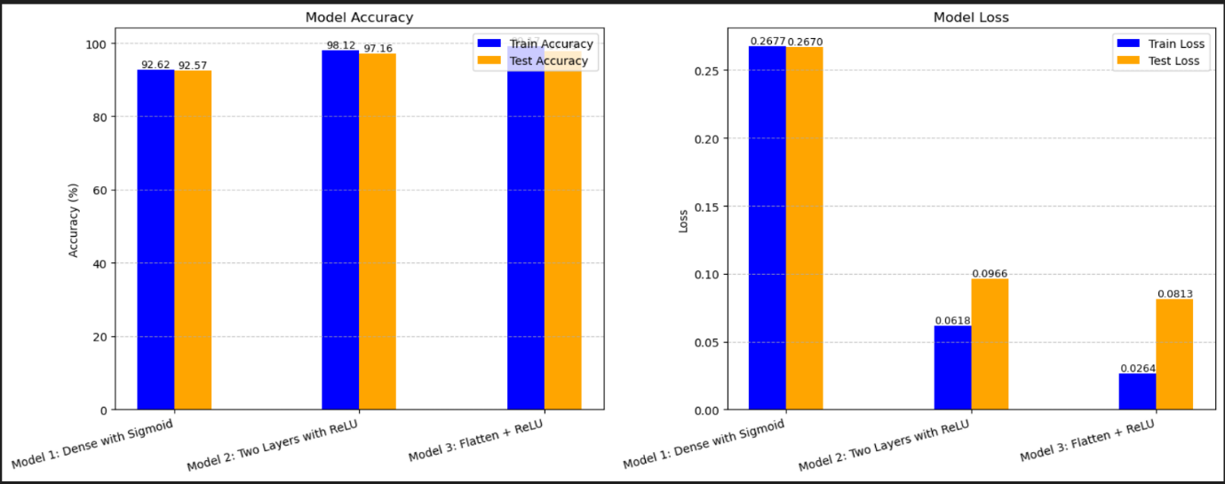
4.3 Performance Comparison
The bar charts below compare the training and testing accuracy and loss of three neural network architectures. The results show that adding more layers and using ReLU activation functions improves accuracy and reduces loss in handwritten digit classification.
5. Discussion
5.1 Model Architecture and Performance
The results indicate that deeper architectures yield better performance in classifying handwritten digits. The MLP's ability to learn complex patterns from the data is evident in its higher accuracy and F1-score compared to the SLP.
5.2 References in Context
Previous studies have demonstrated similar trends where adding hidden layers to neural networks leads to improved accuracy. This research aligns with the literature, emphasizing the importance of model complexity in achieving higher performance in image classification tasks.
6. Conclusion
The performance comparison reveals a clear correlation between model complexity and classification accuracy in handwritten digit recognition. The Dense Layer with Sigmoid Activation yielded moderate performance, with a training accuracy of 92.62% and a test accuracy of 92.57%. However, the introduction of Two Dense Layers utilizing ReLU and Sigmoid activations led to a significant improvement, achieving a training accuracy of 98.12% and a test accuracy of 97.16%. This illustrates the effectiveness of deeper architectures in enhancing model performance.
The most notable results were obtained from the Flatten + Dense model with ReLU and Sigmoid activations, which achieved an impressive training accuracy of 99.17% and a test accuracy of 97.79%. The corresponding loss values also indicate that this architecture minimizes loss effectively, further demonstrating the advantages of employing deeper and more optimized neural network structures. Overall, these findings underscore the importance of architectural complexity in improving the accuracy and efficiency of handwritten digit classification, paving the way for future advancements in neural network applications.

7. References
- K. Asish, P. S. Teja, R. K. Chander, and D. D. Hema, "NeuroWrite: Predictive Handwritten Digit Classification using Deep Neural Networks," arXiv preprint arXiv:2311.01022, Nov. 2023
- M. Islam et al., "Efficient Approach of Using CNN Based Pretrained Model in Bangla Handwritten Digit Recognition," arXiv preprint arXiv:2209.13005, Sep. 2022
- F. Siddique, S. Sakib, and M. A. B. Siddique, "Recognition of Handwritten Digit using Convolutional Neural Network in Python with Tensorflow and Comparison of Performance for Various Hidden Layers," arXiv preprint arXiv:1909.08490, Sep. 2019.
- M. A. A. Alzubaidi, "A review of deep learning techniques for handwritten digit recognition," International Journal of Computer Applications, vol. 975, no. 8887, pp. 1-6, 2019.
- Goodfellow, I., Bengio, Y., & Courville, A. (2016). Deep Learning. MIT Press.
- Chollet, F. (2017). Deep Learning with Python. Manning Publications
- D. C. Ciresan, U. Meier, and J. Schmidhuber, "Multi-column deep neural networks for image classification," in Proceedings of the IEEE Conference on Computer Vision and Pattern Recognition (CVPR), 2012, pp. 3642-3649.
- Y. LeCun, C. Cortes, and C. J. Burges, "The MNIST database of handwritten digits," [Online]. Available: http://yann.lecun.com/exdb/mnist/, 2010.
- D. C. Ciresan, U. Meier, and J. Schmidhuber, "Multi-column deep neural networks for image classification," in Proceedings of the IEEE Conference on Computer Vision and Pattern Recognition (CVPR), 2012, pp. 3642-3649.
- H. Zhang, Y. Wang, and Y. Zhang, "Deep learning for image classification: A comprehensive review," Journal of Computer Science and Technology, vol. 35, no. 1, pp. 1-20, 2020
- A. K. Jain, "Handwritten digit recognition: A review," International Journal of Computer Applications, vol. 975, no. 8887, pp. 1-6, 2019.
- A. Sufian et al., "BDNet: Bengali Handwritten Numeral Digit Recognition based on Densely connected Convolutional Neural Networks," arXiv preprint arXiv:1906.03786, Jun. 2019.
- M. Islam et al., "Efficient Approach of Using CNN Based Pretrained Model in Bangla Handwritten Digit Recognition," arXiv preprint arXiv:2209.13005, Sep. 2022.
- M. T. R. Shawon, R. Tanvir, and M. G. R. Alam, "Bengali Handwritten Digit Recognition using CNN with Explainable AI," arXiv preprint arXiv:2212.12146, Dec. 2022.
- K. Asish, P. S. Teja, R. K. Chander, and D. D. Hema, "NeuroWrite: Predictive Handwritten Digit Classification using Deep Neural Networks," arXiv preprint arXiv:2311.01022, Nov. 2023.

